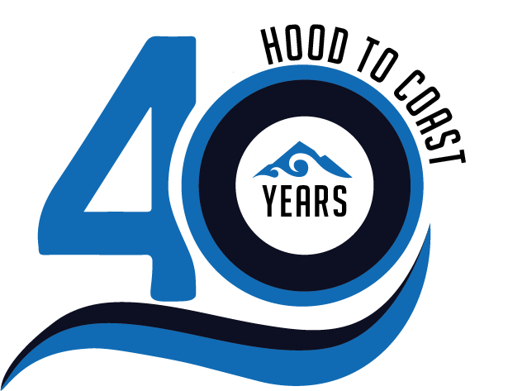
2022 Key Dates / Registration + Participation
April 14th- Last Day to Order Extra Medals- Available online HERE. Pick-up extra medals at the Finish Party.
June 9th- Last Day to Update Your Shirt Size OR Order Extra Shirts -Size and quantity that you have on your roster on this date is what you will receive at packet pick-up. Any t-shirts submitted after this date will receive remaining sizes that are available. Available online HERE. Pick-up extra t-shirts at the Finish Party.
June 16th- Teams must have a Minimum of 8 members on their roster in order to participate.
June 22st- Last Day for Free Additions/Substitutions- After this day, adds/subs to your team roster are $20 per person or $25 per person on race day at the Start Line. Add teammates to your team roster in the Team Clubhouse.
June 23th- Last Day to Update Your Individual Race Pace in the Team Clubhouse- A minimum of 8 team members must update their most accurate race pace by this date in order to receive a start time. Submit your most accurate/up-to-date race pace in the Team Clubhouse.
July 6th- Local Teams Begin Inviting your Three (3) REQUIRED volunteers- Starting at 10am PST, check your Team Clubhouse account for the “Add Volunteer” button. Invite your volunteers to the volunteer portal via email (verify with volunteers that they have received this email).
July 7th- Volunteer Registration and Job Selection Opens- Starting at 8am PST, volunteers will follow the registration link in the email that was sent. We highly recommend using Google Chrome and not attempting to register via smartphone (please use an iPad or laptop/PC).
July 15th – Last Day to Update Emergency Contact information in Registration. Emergency Contact Information will be printed on the back of your race bib on this date.
July 15th- Last Day for Team Name Changes- Your team name will be printed on your race bib on this date.
August 2th- Volunteer Training Closes- Closing at 11:59pm. Volunteers who have completed the online training and have NOT selected a volunteer position will be randomly assigned to a position on 8/4. These random job assignments CANNOT BE CHANGED once assignments are issued.
August 4th- Packet Hold Issued to Local Teams with Fewer than Three (3) Volunteers- These teams will NOT be able to pick up their race bag at packet pickup. Race bags include necessary materials to participate in the event will be held until 3 volunteers have been confirmed.
August 8th- Start Times Posted- Login to your Team Clubhouse account to view
August 8th-12th-DRIVE-THRU Packet Pickup
  - Hood & Portland To Coast Office
- Durham Road, Portland, OR 97224
  - Get your awesome race shirts, important event reminders/info, race bibs, van signs, find out your team start time and receive a bag of sponsor goodies!
  - Schedule & Times TBD
August 13th- Virtual Exchange Leader Training 12:00 p.m. – 1:00 p.m. PST
August 22nd- Team Pre-Check Presented by Alaska Airlines Opens 6:00AM PST via Hood To Coast App
August 25th- Team Pre-Check Presented by Alaska Airlines Closes 12:00 PM PST via Hood To Coast App
August 26-27th- The 40th Anniversary of Hood To Coast & 31st Annual Portland To Coast: Race Day! Let’s rock The Mother of All Relays!
August 27th- HTC and PTC Relays Women’s, Men’s, and Mixed Category Winning Teams Announced & Providence Cancer Institute Fundraising Totals.
August 28th- Top 6 teams in each Category Awards- Given out on a pick-up basis anytime from 9:00am-11:00am only on the beach for Hood To Coast, PTC Walk, and Portland To Coast Challenge Relays.

